Game Design Document

Fill up the following document

1. Write the title of your project. Space wanderer
2. What is the goal of the game?

To defeat aliens while dodging obstacles to find a new planet.

1. Write a brief story of your game.

1000 years from now, most of mankind has perished and Earth has become inhabitable. With the last ten thosand people left, humans have abandoned Earth and are in the search of a new player. Among the people 3 experts have been chosen to go and find a new planet for mankind to live in. All three of them have to wander in the space while fighitng aliens to find a habitable planet. The fate of mankind rests in their hands.

1. Which are the playing characters of this game?

* Playing characters are the ones who respond to the user based on the input from the user.
* Cars, monkeys, dinos, wizards, etc., are the playing characters in the game.

|  |  |  |
| --- | --- | --- |
| Number | Character Name | What can this character do? |
| 1 | spaceShip1 | Make copies of itself |
| 2 | spaceShip2 | Make time slow down for enemies |
| 3 | spaceShip3 | Become invisible for some time. |
| 4 |  |  |
| 5 |  |  |
| 6 |  |  |
| 7 |  |  |
| 8 |  |  |

1. Which are the Non-Playing Characters of this game?

* Non-Playing characters are the ones that don't have an action or behavior when the user interacts with the game.
* Hurdles, stones, bananas, coins, etc., are non-playing characters in the game.

|  |  |  |
| --- | --- | --- |
| Number | Character Name | What can this character do? |
| 1 | Lackey(alien) | Bump into you and self destruct |
| 2 | Minister (alien) | Can shoot your ship down from a distance |
| 3 | Boss(alien) | Has different abilities according to different levels |
| 4 | Asteroids(obstacle) | Can inflict damage by bumping |
| 5 |  |  |
| 6 |  |  |
| 7 |  |  |
| 8 |  |  |

Draw your imagination of this game. What does this game look like?

* Draw the game either on your computer or on paper.
* Add images of the game scenes to show each of the playing and non-playing characters at least once.

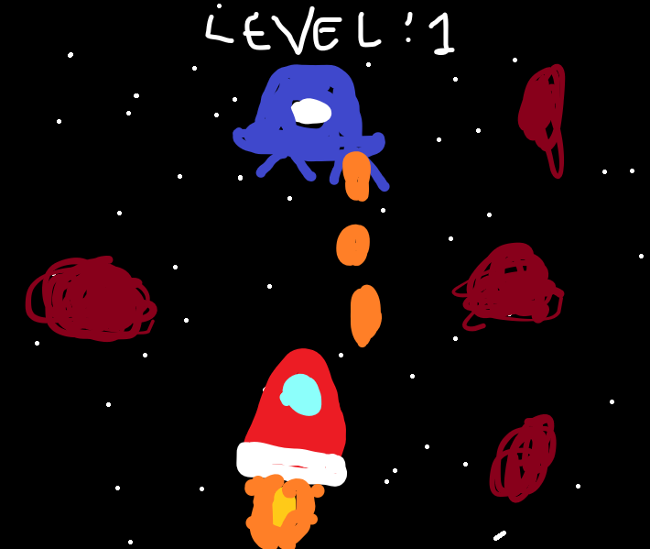

How do you plan to make your game engaging?

By giving bosses of each level different abilities.

By giving powerups to the player.